

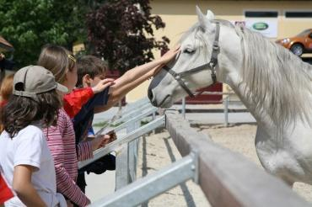

Lipizzanergestüt Piber

Piber 1

8580 Köflach

(T) +43 3144 3323 100

(E) office@piber.com

(I) www.piber.com